**Password Validator**

1. **Task Description**

Create a password validator in React that evaluates user-entered passwords based on specific criteria, such as length, inclusion of uppercase and lowercase letters, numbers, and special characters. The validator provides instant feedback by categorizing the password strength as "Good," "Very Good," "Strong," or "Excellent," depending on the number of criteria met.

1. **Task Output Screenshot**

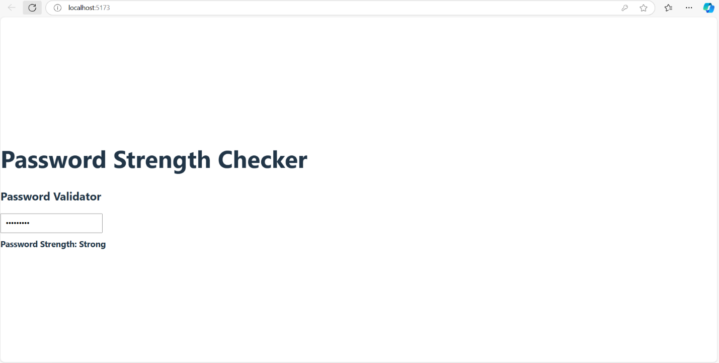

1. **Widget/Algorithm Used In Task**

• **Regular Expressions**: Utilizes regex patterns to check for the presence of various criteria, such as uppercase letters, lowercase letters, numbers, and special characters, allowing for efficient validation of the password.

• **Strength Evaluation Logic**: Implements a scoring system that assesses the password based on the number of criteria met, assigning strength ratings like "Good," "Very Good," "Strong," and "Excellent.

• **State Management**: Uses React's state management to track the password input and its corresponding strength rating, ensuring real-time feedback as the user types.

• **User Interface Components**: Constructs a user-friendly input field and display elements to show the strength rating, providing immediate visual feedback to the user on their password choice.